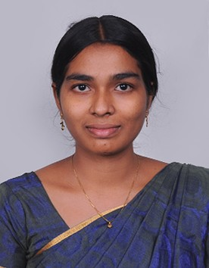
Jemil Vemy V M,
#148, Ground Floor, 2nd main, 2nd cross,
Sadanandanagar, NGEF Layout,
Bangalore, Karnataka, 560038.
Mobile: +91 8903402162
E-Mail: vmvemy@gmail.com
Objective:
I am now looking to build on my extensive range of technical skills within a suitably challenging role. I am keen to achieve further professional development in the field of Science and Technology and to bring the Organization name across the globe.

Career Experience:
- Worked as an Assistant Professor in CMS College of Engineering and Technology, Coimbatore, Tamilnadu, India, from 21 June 2012 to 08 December 2015.
Academic Profile:

Degree | College/University | Year of Study | Percentage
M.E. CSE | Tagore Engineering College, AUT, Chennai. | May 2012 | 83%
B.Tech I.T | St. Xavier’s Catholic College of Engineering and Technology, AU, Chennai. | May 2010 | 80.9%
XII | L.M.S. Girls Hr. Sec. School Neyyoor, Tamilnadu, India. | April 2006 | 82%
X | L.M.S. Girls Hr. Sec. School Neyyoor, Tamilnadu, India. | April 2004 | 87%

B.E. Project:

Title : Spot Keywords from Document Images to Retrieve Document
Description : The project spots keywords from scanned document images using MatLab software. It takes scanned documents and keyword as input and produces the matched documents.

M.E. Project:

Title : Query Expansion Using Semantic Similarity Computation
Description : The project is used for document (web pages) retrieval efficiently. It takes a query as input and expands it based on past history and semantics.

Roles and Responsibilities:
- Represented as Department Association Coordinator
- Represented as Faculty Advisor for B.E., students.
- Counseling member in student parents committee meeting

Seminar/Career Development Programs/Achievements:

- Participated in one week Faculty Development Program by ICTACT from 20th January to 25th January 2014 at CMS College of Engineering and Technology (CMS CET), Coimbatore
- Participated in the workshop on “Next Generation Wireless Networks” organized by the Department of Information Technology of Sri Sai Ram Engineering College on 10th and 11th March 2011.

Technical Proficiencies:

Languages : C, C++, Java, HTML, CSS, JavaScript
IDE : Eclipse
Database : MySQL

Personal Profile:
Father Name : Vedhamonickam N
Gender : Female
Marital Status : Married
Date of Birth : 03.04.1989
Nationality : Indian
Languages Known : Tamil, English, and Malayalam

DECLARATION
I hereby declare that all the particulars stated above are true to the best of my knowledge and belief.

Yours Sincerely,
Jemil Vemy V. M.

